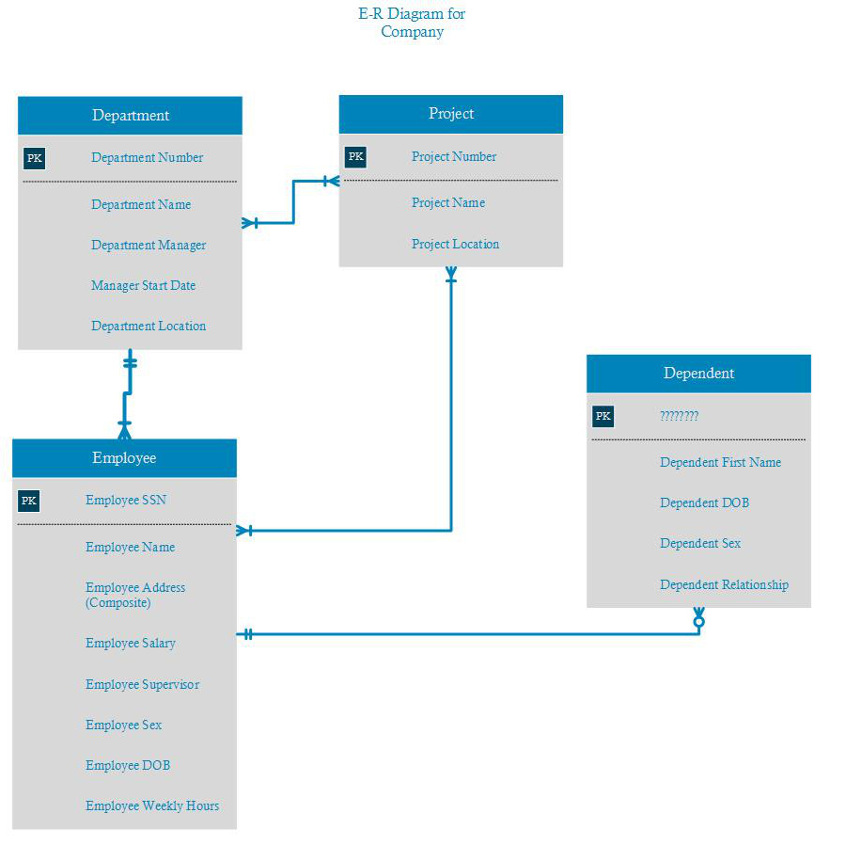

attributes were listed pretty clearly in the requirements with statements like:
- Each department has a name, an unique number,
- keep track of the start date when the employee began managing the dept
- projects, each of which has a name, unique number,
- store each employee’s name, SSN, address, salary, sex, and DOB.

